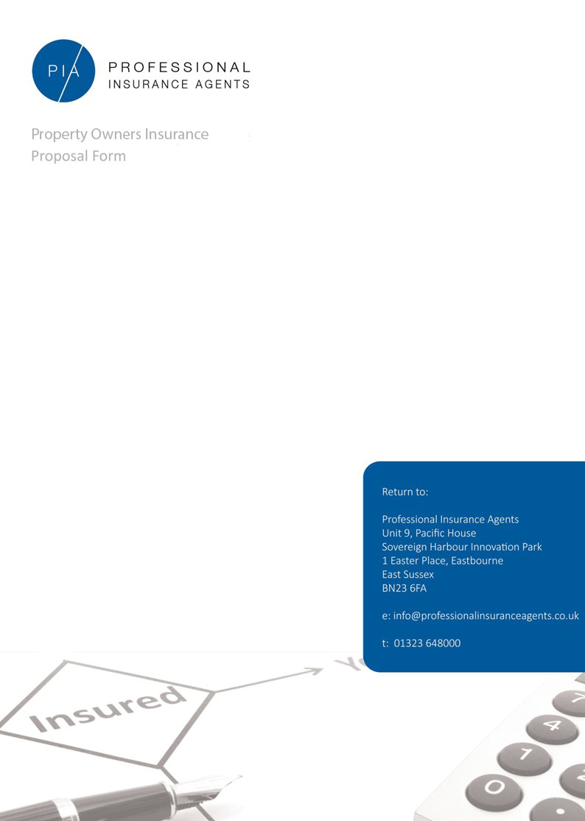

Property Owners Insurance

Policy Information

Trading Name:
Start Date: End Date:
Correspondence Address:
Is The Insured UK Domiciled?:
* If Answered No, Please Be Advised We Will Not Be Able To Assist
How Many Years Have You Been In Business?:

Insured Item
* Please Copy And Repeat For Multiple Premises
Risk Address:
Specified Trade:
Percentage Uplift:
Years Premise Owned And Insured:
Is There A Basement?:
How Many Storeys (Including Basement?):
Is The Premise: Detached / Semi-Detached / Terraced / Multi-Tenure
(If Multi-Tenure, Please List All Tenants):
When was the property built?
Construction Type (Walls, Roof, Floors, Stairs):
Is The Premise Occupied?:
(If No, Please Advise Of The Following):
- How Long Has The Premise Been Unoccupied?:
- Who Was The Previous Tenant?:
- Will There Be A Change Of Use?:
- What Does The Insured Plan On Doing?:
- Has Planning Permission Been Granted?:
- Are All Mains Services Off?:
Are There Any Notable Interest?
(If Yes, Please State Who):
Does The Premise Have Composite Panels?:
(If Yes, Please Provide Details):
Does The Premise Have A Thatched Roof?:
Does The Premise Have Any Portions Of Flat Roof?:
Is The Property Listed?:
(If So What Is The Grade?):
Has The Premise Had An Electrical Inspection Within 5 Years?:
What Type Of Heating Does The Premise Use?:
Does The Premise Have An Automatic Fire Alarm?:
Does The Premise Have An Intruder Alarm?:
Does The Premise Have Sprinklers?:
Does The Premise Have Roller Shutters?:
Is The Premise Showing Signs Of Subsidence, Ground Heave or Landslip?:
Is Accidental Damage Cover Required?:
Is Subsidence Required?:

Insured Figures

* Please Answer Only Those Required
Buildings Declared Value:
Glass Limit:
Loss Of Rent:
Indemnity Period (Months):
Property Owners Liability Value:
Landlords Contents:
Tenants Improvements:
Employers Liability (Clerical / Caretakers / Maintenance Staff):

Declaration

Has The Proposer, Any Director Or Partner In The Business…
Had Insurance Refused, Declined Or Cancelled?:
Had Any Special Terms Imposed On An Insurance Policy?:
Been Convicted, Charged Or Cautioned For Any Criminal Offence?:
Been Declared Bankrupt, Insolvent, Subject To Any Proceedings, Have Any County Court Judgements Or Disqualifications As Company Director?:

Claims Experience

Has The Insured Had Any Claims Within The Last 5 Years?
(If Yes, Please Answer The Following For Each And Every Claim):
- Claim Date:
- Amount:
- Status:
- Type Of Claim:
- Address Of The Claim Location:
- Details About The Claim:
Additional Information

Please Advise Of Any Further comments:

Declaration

I / We declare that the statements and particulars in this proposal and submission are true and I / We have made a fair presentation of the risk, by disclosing all material matters which I / We know or ought to know or, failing that, by giving the Insurer sufficient information to put a prudent Insurer on notice that it needs to make further enquiries in order to reveal material circumstances. Furthermore, I / We will agree to inform Insurers of any material alterations to my / our circumstances that may occur before or after the completion of any contract of insurance offered to me / us by the Insurer

Signature of Principal / Partner / Director:

Full Name:

Date:

**By signing this declaration, on behalf of our company and any applicable employees, we are also consenting to PIA sending relevant insurance information to us as part of their services. This consent can be withdrawn at any time by giving written notice to PIA.

Please note that returning this proposal does not bind the Proposer or Underwriter to complete this insurance but does authorise ‘Professional Insurance Agents’ to seek terms on my/our behalf from Insurers, including current Insurers

Please Check To Ensure All Details Are Answered Accurately

Thank You For Your Assistance

